**Distribute Your App Across a Swarm Cluster.**

2 instance created web1, web2:

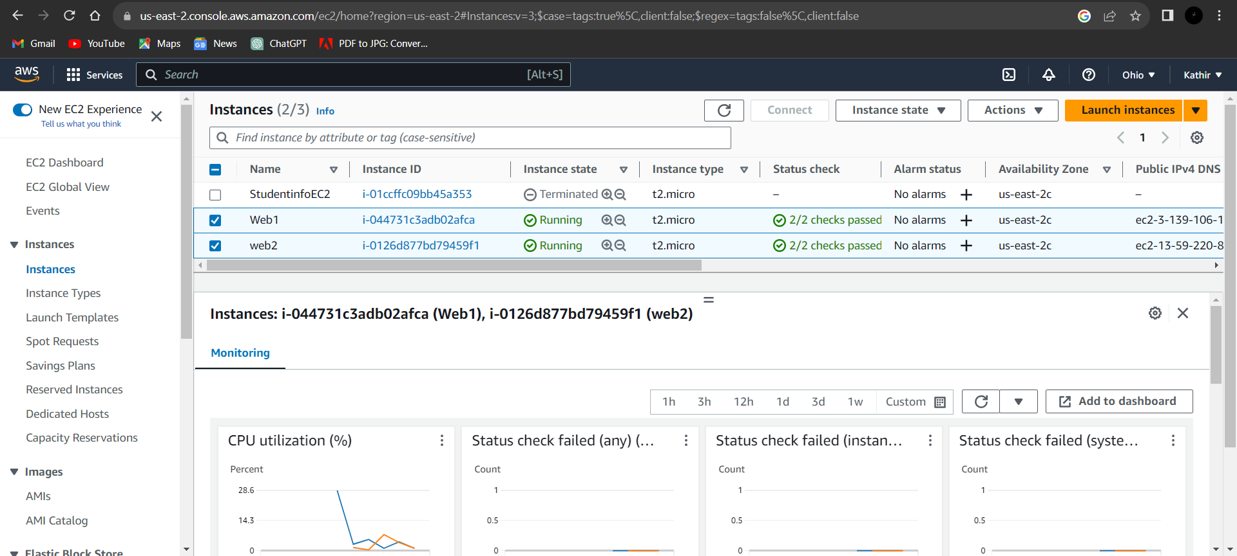

Manager

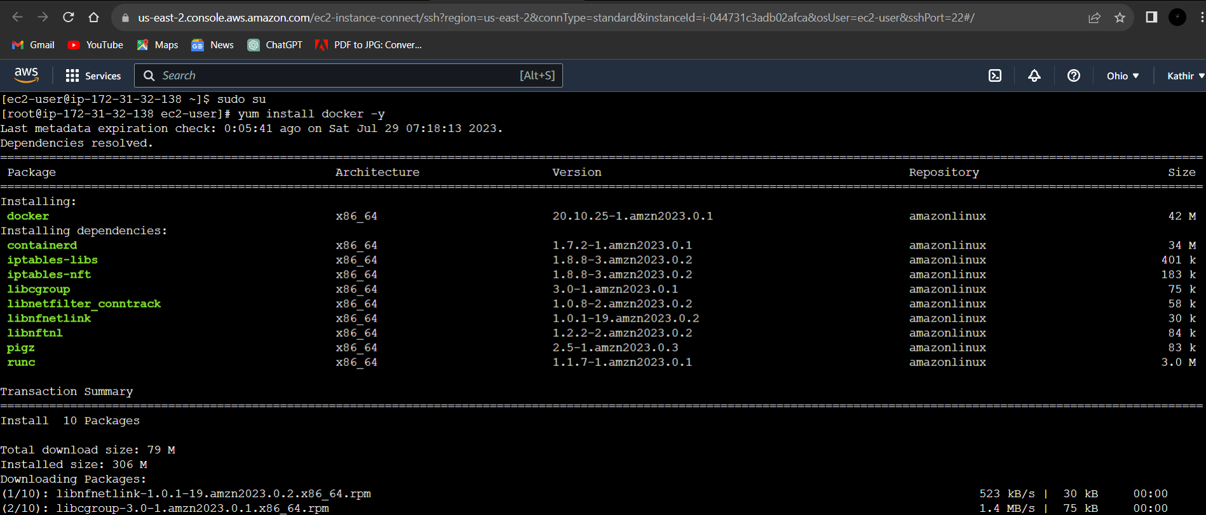

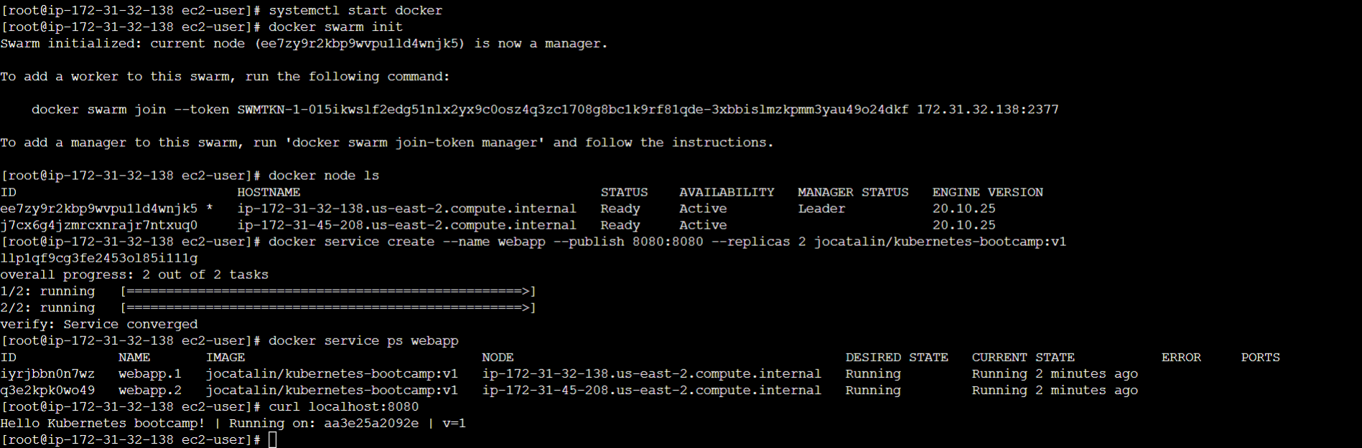

Worker

